**How to RUN (README)**

1. Install the “eclipse-inst-win64.exe” > Select > (2nd option) JAVA EE for ECLIPSE IDE Developers. (Default installation path).
2. Install java JDK version "1.8.0_192". (Default installation path)
3. In your E:/ drive create a folder name “My_Workspace” and extract the rar contents to that folder such that

“E:\My_Workspace\My_Eclipse_Workspace_AOS_Project”

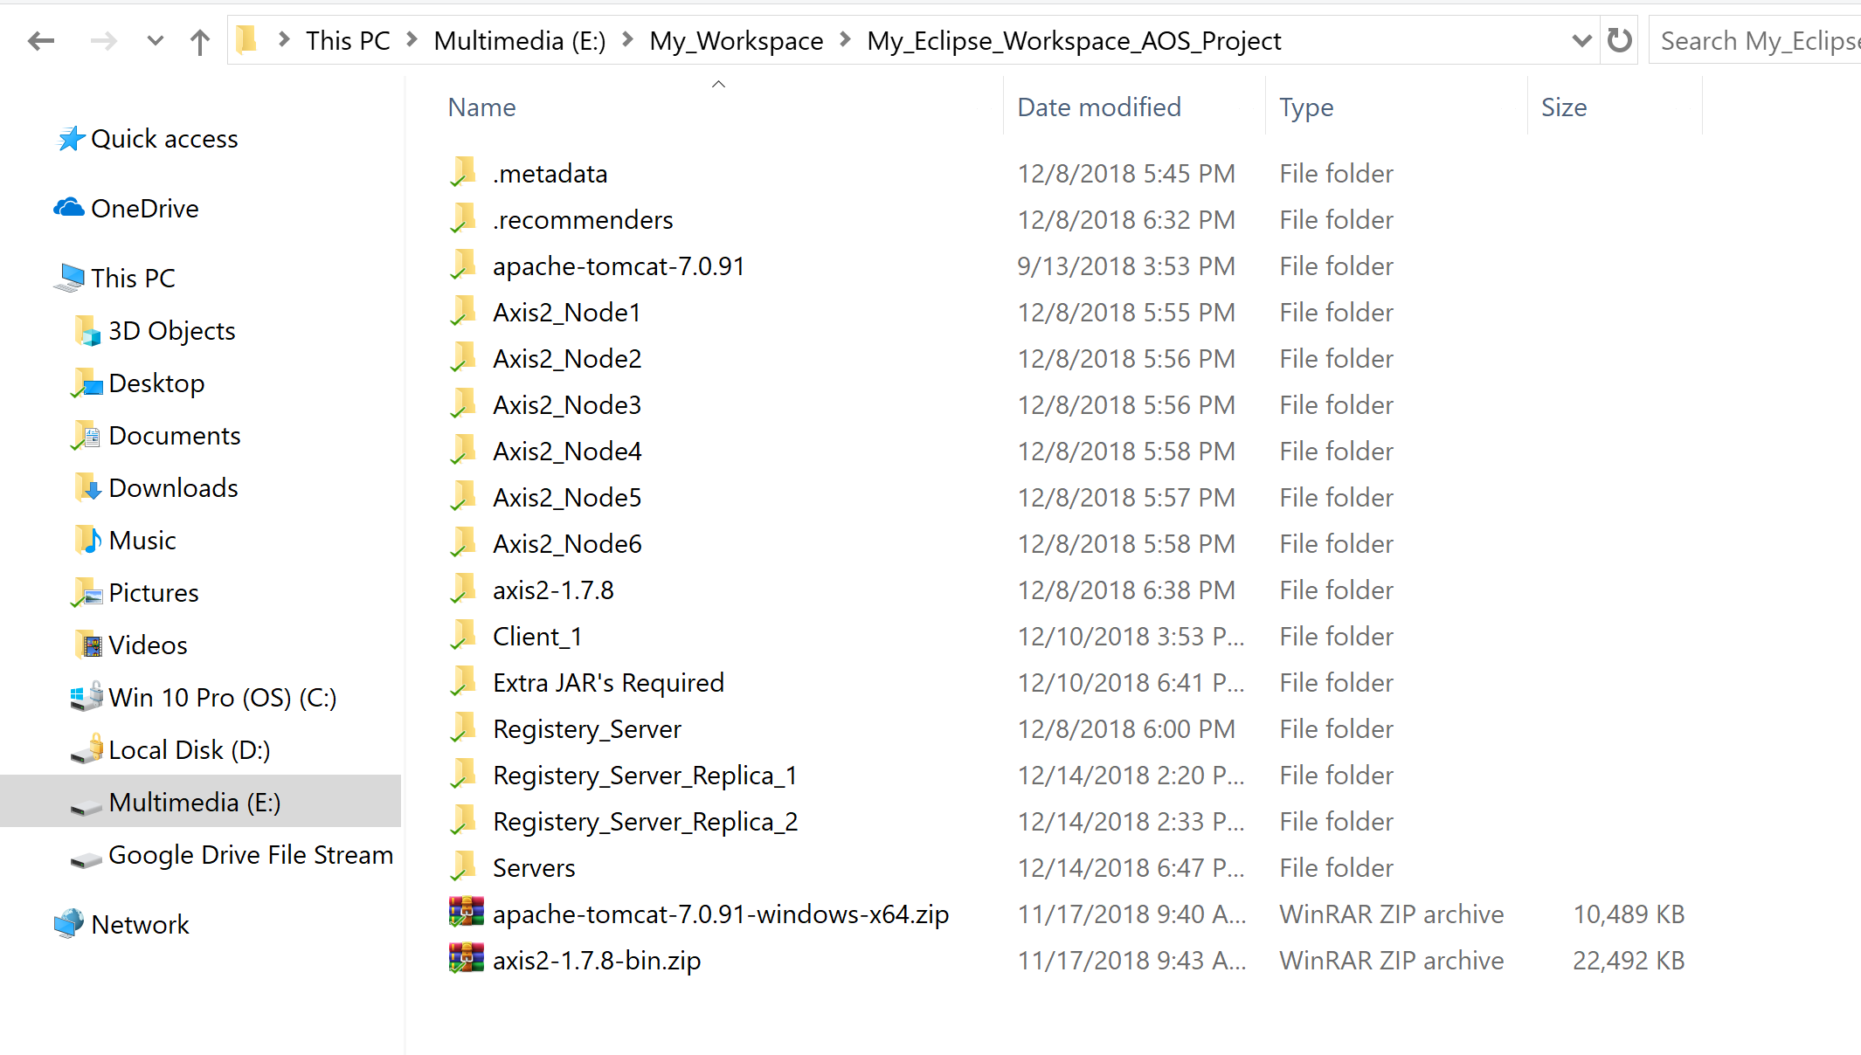

1. Now start your Eclipse IDE in Administrator Mode.
2. Select workspace as :” E:\My_Workspace\My_Eclipse_Workspace_AOS_Project”
3. Go to Workbench
4. Go to Servers Tab and Start the Servers(By cright clicking the tomcat servers in the ‘Servers’ tab) in following sequence -> (refer the screenshot below)
   1. [RS] – Main Registery_Server
   2. [RS_R2] – Replica 1 of registery Server
   3. [RS_R3] – Replica 2 of registery server
   4. You can start the other Node Servers (N1,N2,N3,N4,N5,N6) in any sequence.

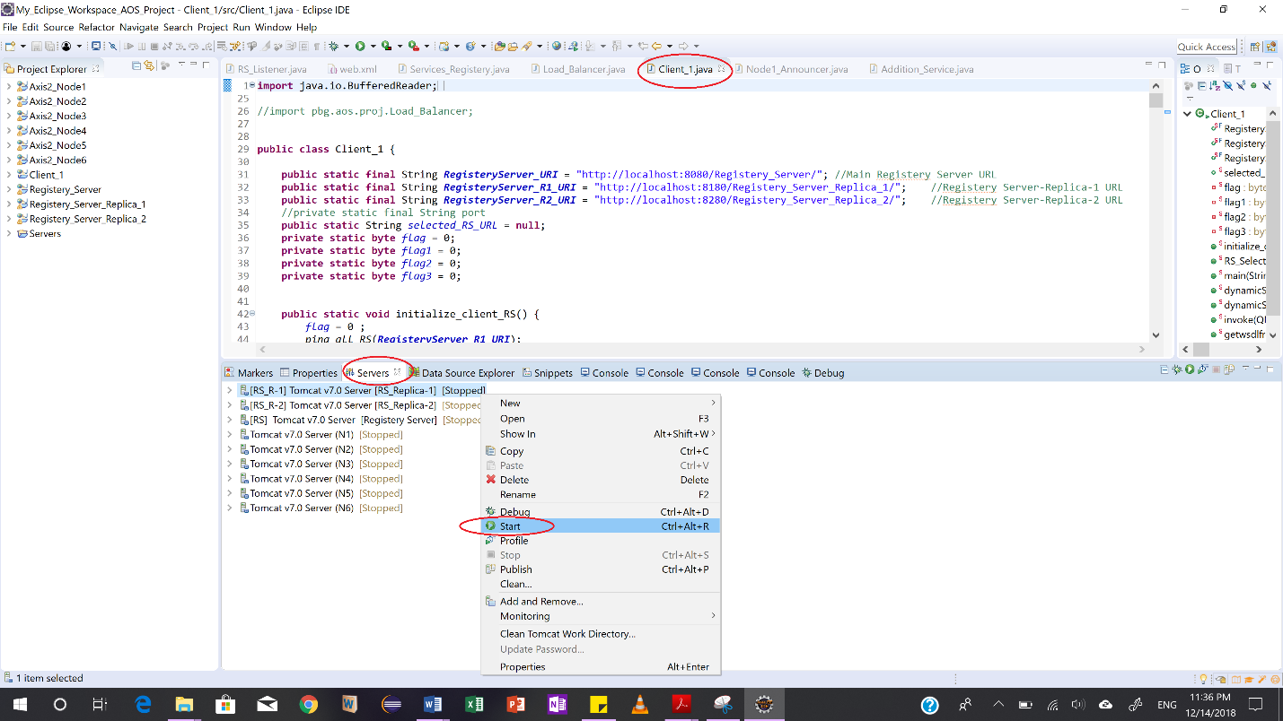

1. Click on the Client1.java (note that this is not deployed on any server, it’s just a normal java program can be run from anywhere). Also, this is a single program, instead of replicating it , we can run the same program multiple times at a time from eclipse to emulate that multiple clients are running on multiple consoles.
2. You will want to create multiple console views to observe the output of different servers. (you may want to ‘Pin the console’ with the different server console views to make things easier).
3. Now you can run this client program – which is self descriptive in what you have to do , a simple choice selection in it.
4. I have commented the code in following java files(which are replicated across the project but without comments)

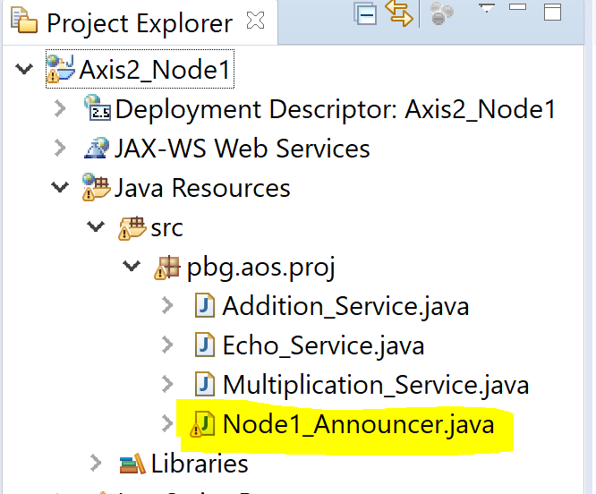

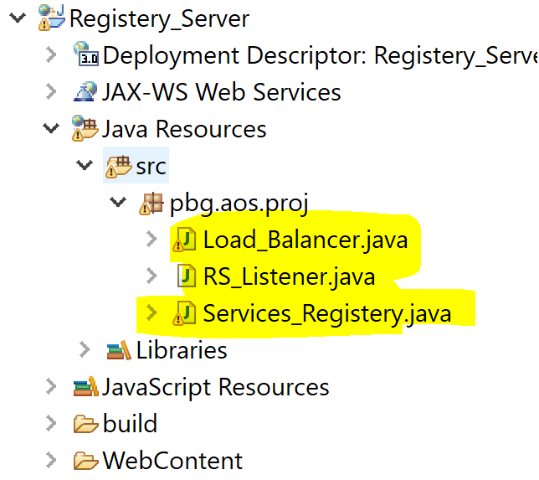

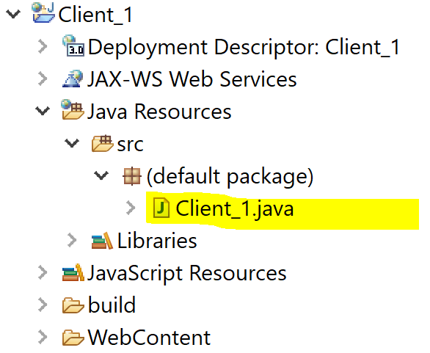

1. Assuming you will be running this project on a same machine I have made things simple and created this setup., if you wish to run it on multiple machines we will have to change the URL’s which are hardcoded for REGISTERY SERVERS. (which I will demonstrate on demo day).